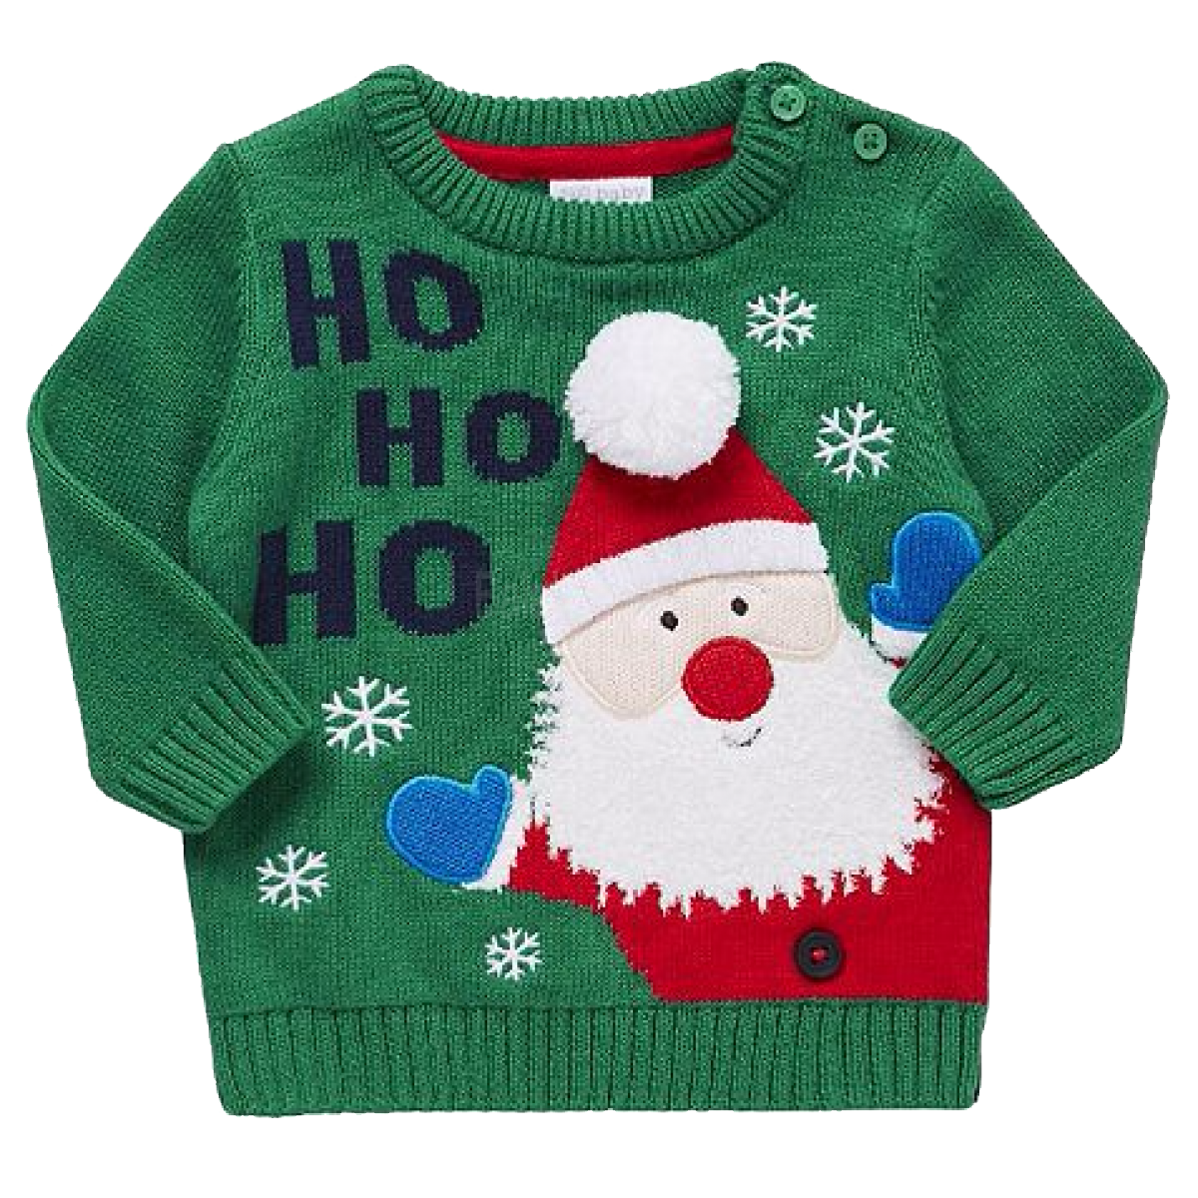 Ugly Sweater Holiday Tennis Social

Friday December 2nd
6:30pm to 9:30pm

Adult Mixed Doubles & Youth Doubles Round Robin

We will be rockin current and classic Holiday tunes!

Play some fun social tennis
Raffle for prizes
Ugly Sweater Contest

Entry Deadline – November 30th

$30 per person

Players will play 4 rounds. Every player will receive a raffle ticket upon check-in and earn extra tickets with each round won. We’ll have pizza after the tennis around 9:00pm.

Paseo Racquet Center * 6268 West Thunderbird Road * 623-979-1234
- - - - - - - - - - - - - - - - - - - - - - - - - - - - - - - - - - - - - - - - - - - - - - - - - - - - - - - - - - - - - - - -
Name_________________________________________________________Phone____________________________
Address________________________________________________City__________________Zip_________________
email_________________________________________________________Cell_______________________________

Doubles Partner________________________________________________Phone____________________________

Adult Mixed Doubles ____ Youth Flight____

